AutoPeer: LLM-Assisted Academic Paper Review System with Multi-Role Prompting

Part A: The Vision

1.0 Abstract
At present, academic peer-review process has faced a series serious problem, such as review process cost long time, comments are often vague and many automated tools only available to short essays rather than long academic articles. At the same time, large language models (LLMs) are being developed in building new process tools, while they are still hard to deal with long professional stories, always giving positive feedback to all papers. Besides, it sometimes ignores significant academic criteria (reproducibility and ethics). Based on these challenges, this project proposed AutoPeer, an AI-powered assistant designed specifically for reviewing long academic papers. AutoPeer includes several key components. Firstly, using data pipelines to extract the structure of long papers(sections, paragraphs, experiments). Every divided part will be reviewed in order, thus our system knows which part is being handled. Secondly, we use multi-role prompting to simulate different reviewer’s type. Thirdly, we introduce a six-dimension scoring framework covering clarity, rigor, novelty, contribution, reproducibility, and ethics. These six aspects are mostly missed by current system. All the outputs are based on strict JSON structure and include direct links or references to the original text. The system also concludes reduce bias strategies and privacy safeguards to avoid unfair judgement and protect data safety.

2.0 Introduction & Motivation

Problem Statement
Currently, academic peer-review processes are facing several challenges. Existing automated feedback tools mainly target short essays, so they cannot handle the complex structure of long academic research papers and give proper feedback. Besides, many LLM-based reviews are too general, overly positive, or lack of critical details. Some important academic aspects—such as reproducibility, ethical considerations, and evidence-based reasoning—are rarely included. Additionally, LLM output often contains language or cultural bias, and current systems do not provide strong privacy protection for confidential manuscripts. Those issues create inefficiency, inconsistent review quality, and potential unfairness.

Project Goals
This project aim to provide a precise analysis for long academic papers and achieve automated reviews that can accurately assess each paragraph. AutoPeer seeks to combine structured document analysis, multi-role prompting, and a tailored academic scoring framework so that the feedback becomes more precise, critical, and practically useful. What’s more, the system aims to reduce bias, protect manuscript confidentiality by giving some prompts, and ensure that all comments can be traced back to the original text through a transparent output format. We will also present the model output in a structured and interactive interface to facilitate people's verification and use. The overall goal is not to replace human reviewers, but to use a tool to help them improve efficiency.

Significance
Using AutoPeer to solve the problems we list above can help conference organizers, journal editors, students, etc. solve a series of problems regarding the academic peer-review process. For the organizers of conferences (ACL, NeurIPS) and journal editors, the structured output and scoring criteria designed by our AutoPeer can significantly alleviate the burden of review, provide initial screening and preliminary quality control. For reviewers, they can gain a tool that highlights potential issues they might overlook, helping them provide fairer and more comprehensive assessments. As for personal authors, especially students and early-career researchers, receive clearer and more actionable suggestions that help them strengthen their work before submission. Last but not the least, the system emphasizes ethics and privacy, which helps prevent abuse and establish a trusted AI-assisted review process.

Part B: The Foundation

3.0 Literature Review

3.1 Introduction to the Literature Review
The automation of academic paper evaluation has long been a pursuit at the intersection of natural language processing (NLP) and educational assessment. This literature review concentrates on the evolution of automated essay/paper scoring (AES/APSR), text summarization for contribution extraction, and feedback generation, with a focus on their application to peer review in high-impact venues such as ACL and NeurIPS. We begin by examining traditional NLP methods which played a vital role to 2018, for example feature-engineered statistical models and rule-based systems [1]. These approaches made huge progress but were limited in semantic depth and adaptability to complex academic texts. The emergence of Large Language Models (LLMs), beginning with GPT-3 [2] and accelerating through LLaMA and GPT-4, has developed zero-shot reasoning, structured output, and reviewer simulation at large scales [3, 4], though their performance in automated essay scoring remains below traditional state-of-the-art methods. This paper will trace this evolution step by step. In the end, we will point out the current shortcomings, such as insufficiently detailed scoring criteria, overly broad feedback, susceptibility to bias, and unresolved ethical issues. Our AutoPeer system aims to fill these gaps with structured prompts, multi-dimensional scoring, and human-aligned evaluation.

3.2 Traditional NLP Approaches for Automated Scoring and Feedback Generation
Automatic essay scoring (AES) is one of the earliest applications of NLP. Early systems began in the 1960s, which mainly used surface features such as word count, sentence length, and lexical diversity. After 2000, commercial systems such as e-rater introduced statistical machine learning. These systems extracted features such as syntactic complexity and text markers. They used support vector machines or linear regression for scoring. On standard datasets, quadratic weighted Kappa (QWK) reached 0.70–0.76 [1]. Traditional methods perform well in educational settings. However, they have significant shortcomings in academic paper scoring. First, they lack semantic understanding. They cannot assess the rigor, innovation, or domain contribution of the method. Second, they have poor domain transferability. Models trained on K-12 argumentative papers show a performance drop of more than 30% when applied to scientific papers [1]. Third, the feedback generation method is limited. The system can only output templated suggestions such as "improve clarity". It cannot cite specific paragraphs of the paper. Text summarization technology is also used to extract the core content of papers. Early methods employed extraction-based approaches. For example, TextRank ranks sentences by their lexical overlap within a graph-based ranking framework [5]. However, it cannot assess the validity of a contribution. Generative summarization uses RNN or LSTM models [6]. These methods can rewrite sentences, but they are prone to producing illusions or repetitive content and they are not good at handling technical terms. In terms of feedback generation, traditional systems rely on rule templates. Yadav proposed a method for evaluating peer review quality [7]. Their system uses word-order graphs and semantic analysis to identify the content type and tone of reviews, such as distinguishing between summary, problem detection, and advisory content. While the system effectively evaluates the relevance and coverage of existing feedback, it does not generate new suggestions for the authors. However, it does assess contextual relevance between the review and the submission, contrary to systems that rely solely on surface-level features.
Traditional fuzzing such as AFL is inefficient when dealing with structured inputs and cannot reach deep code through syntax checks [8]. NAUTILUS combines context-free grammars (CFG) and coverage feedback to generate grammatically correct inputs and found 13 vulnerabilities in interpreters such as ChakraCore and PHP. This highlights the need for similar grammatical guidance in modern AES to handle the “structured semantics” of academic papers.
Traditional NLP methods are effective in structured tasks, such as grammar checking and keyword extraction. Nevertheless, they fall short in academic peer review. What’s more, they cannot perform holistic reasoning or provide constructive feedback on citation support.

3.3 Evolution from Traditional NLP to LLM Methods
Large Language Models (LLMs) have revolutionized the field of automatic scoring [9]. BERT and RoBERTa introduced a pre-training + fine-tuning model. They far surpass traditional feature engineering in semantic understanding.
In 2020, GPT-3 first at-scale demonstrated zero-shot learning capabilities [2]. It can complete tasks using only prompts without training data. Han et al. tested GPT-3.5 on IELTS essays [10]. The zero-shot QWK reached 0.68, indicating substantial agreement with human raters and demonstrating that LLMs can quickly adapt to scoring tasks without task-specific training.
The advantages of LLMs lie in contextual reasoning and long text processing. Traditional methods can only look at local features while LLMs can analyze entire papers. The latter support structured outputs, such as scores and reasons in JSON format. Researchers began using LLMs to simulate reviewers. Liang's team evaluated the feedback capabilities of GPT-4 [3]. The model generated peer review comments with a 39% overlap rate with human reviewers. On low-quality papers, the overlap rate rose to 47%, indicating that it can point out factual errors and missing benchmarks, but it is weak in judging originality. Zhou et al. comprehensively tested the reliability of LLM as a peer reviewer [11]. On a set of multiple-choice review-revision questions derived from ICLR 2023 discussions, the models achieved around 60–70% micro-accuracy, but only approximately 20% macro-accuracy on questions requiring constructive suggestions. This indicates that LLMs still struggle to generate fully correct and useful feedback without stronger guidance. Prompt engineering has become increasingly important in LLM-based systems. Atkinson et al. [12] proposed a hybrid approach for automated essay scoring that combines shallow linguistic features with contextual embeddings generated by GPT-3. While the model integrates structured feature extraction, it does not explicitly use JSON hints or structured prompting mechanisms. Similar to NAUTILUS grammatical mutations, such as rule mutations and concatenation mutations, LLM hint engineering can reorganize “interesting” input fragments (such as paper abstracts + methods) to improve semantic effectiveness [8]. NAUTILUS’s precomputation (min(n), p(n,l)) inspires LLM’s few-shot example optimization to reduce the illusion in random generation. LLMs enhance scoring flexibility. They support few-shot learning, allowing style mimicry with just a few peer review examples. Compared to traditional methods, LLMs reduce annotation requirements and can handle multi-dimensional criteria such as originality and reproducibility.
However, challenges remain. For example, feedback is often overly positive, with insufficient criticism of weaker papers. Furthermore, LLMS remains inconsistent in handling long texts, exhibiting significant fluctuations in results depending on the feedback provided. Additionally, bias issues persist, with non-native English speakers often being underestimated.

3.4 Current Research Gaps and Challenges
Despite significant progress in LLM, several key gaps remain. First, the research subjects are mismatched. Most work focuses on short essays (such as IELTS and MOOC assignments) [13]. Second, the scoring criteria are incomplete. Existing rubrics lack academic-specific dimensions, such as reproducibility, code usability, and ethical considerations [14]. These are crucial in ACL and NeurIPS peer review but are rarely addressed in LLM research. Third, the feedback quality of LLMs is inconsistent. They tend to generate overly general and predominantly positive comments, even when human reviewers provide critical feedback [11]. Moreover, the generated reviews often lack constructive suggestions, specific citations, and pinpointed critiques at the paragraph or experiment level. Fourth, bias remains a concern: non-native English speakers may receive lower scores, the model shows limited grasp of niche genres such as systematic papers, and skewed training data can fuel systemic injustice [15]. Fifth, the evaluation methods are limited: QWK remains the dominant metric for scoring agreement, and few studies have systematically examined the constructiveness or operability of feedback. Human evaluation of feedback quality has been attempted, yet standardizing and generalizing these dimensions across models and datasets still requires deeper investigation [10]. Sixth, ethical risks remain unresolved. The system may leak paper privacy or be used for plagiarism detection.
Our AutoPeer system will address these issues specifically. We design a 6-dimensional academic rubric, using small sample + thought chain prompts, enforce JSON output + original text citations, introduce multi-role integration (rigorous, constructive, domain expert), and perform dual evaluation of consistency and feedback quality on the ACL real dataset.

Part C: The Blueprint

4.0 System Architecture and Design
Figure 1

4.1 Overall Architecture
Figure 1 illustrates the overall architecture of the AutoPeer system. It is a modular, end-to-end pipeline designed to generate structured review reports from submitted academic papers.
The process begins at the Input Interface, which accepts user-uploaded papers in PDF format. Next, the Intelligent Preprocessing Pipeline​ parses the raw PDF, cleans the text, and performs key structure identification—such as dividing the paper into standard sections (e.g., Introduction, Methodology, Experiments)—to provide structured text for subsequent analysis.
The processed data is then fed into the core Multi-Dimensional, Multi-Role LLM Review Engine. This engine employs integrated prompting strategies and role-playing mechanisms to conduct in-depth analysis and scoring based on predefined academic rubrics.
The engine's output is passed to the Structured Output Generator, which formats it into standard JSON containing scores, fine-grained feedback, and citations. Finally, the Interactive Results Display Interface renders this JSON into a visual report that presents scores and feedback linked to the original text for the end user.

4.2 Data Pipeline
The data pipeline transforms raw academic papers into structured text suitable for in-depth analysis by the review engine. This design directly addresses two core gaps in existing research: tackling the challenge of mismatched research subjects​ by handling genuine academic long papers, and laying the groundwork for fine-grained, locatable feedback​ through precise academic structure identification.
The primary data source for the system is the ACL Anthology, specifically papers from its annual conferences (e.g., ACL 2024, 2023). This corpus is chosen because it provides a large volume of publicly available, high-quality, and relatively well-formatted long papers in computational linguistics. This ensures the system is developed and evaluated using authentic academic long papers, directly addressing the gap of mismatched research subjects.
To build and evaluate the system, two types of data are needed. First, raw paper data​ for system processing, namely the full-text PDFs obtained from the aforementioned source, which constitute the main input for the system. Second, and crucially, evaluation benchmark data—datasets containing the original papers, multi-dimensional human scores (e.g., for clarity, novelty, reproducibility), and detailed textual review comments. This type of data is used to quantitatively assess the agreement between system scores and human scores (e.g., using the QWK metric) and to qualitatively analyze the relevance and constructiveness of the generated feedback.
Regarding Data Pre-processing, raw PDFs require multiple processing steps to be transformed into structured text suitable for large language model analysis. First, the PDF Parsing and Text Cleaning​ stage employs advanced tools like PyMuPDF to accurately extract text and layout information, removing noise such as headers, footers, and page numbers while preserving key academic content like figures and formulas. Subsequently, the core Academic Structure Identification​ module addresses the problem of unfocused LLM analysis caused by complex PDF formats and ambiguous section boundaries. For this, we designed a hybrid approach: a base layer uses a rule-based method, employing regular expressions to quickly match standard section headings like "Introduction" and "Method" for well-structured papers. To enhance robustness, an upper layer introduces a model-based method, utilizing models fine-tuned on academic text (e.g., SciBERT) for sequence labeling to identify and delineate section boundaries in non-standard formats. This strategy balances efficiency and generalizability and is key to enabling targeted analysis. For example, when the system needs to assess a paper's "reproducibility", the preprocessing pipeline can accurately extract the text of the "Methodology" section and feed it along with specific instructions into the review engine. This ensures the generated feedback is highly specific and locatable, directly tackling the challenge of inconsistent feedback quality.

4.3 Core Model(s)
Our system is built on a tiered model strategy designed to balance performance, controllability, and ethical considerations. The core of our system employs GPT-4 as the primary LLM, augmented by LLaMA3 as a contingency for high-privacy scenarios.​ This selection is driven by GPT-4's superior ability to generate scientific feedback that shows significant overlap (30-40%) with human reviews [2], making it well-suited for processing long academic texts. The open-source LLaMA3 serves as a strategically important alternative to mitigate higher API costs and "black-box" concerns, ensuring system functionality where data privacy prohibits external APIs through local deployment, albeit with a potential trade-off in absolute performance [5].
To effectively guide the model's output, we adopt few-shot prompting as our core interaction method, striking a balance between control and cost.​ This strategy provides a pragmatic middle ground: it offers greater stability and task-specific guidance than zero-shot prompting, as demonstrated by its ability to significantly improve scoring consistency (QWK) [6], while avoiding the extensive data and computational resources required for full fine-tuning. By supplying the model with curated examples of high-quality reviews, we directly steer it towards generating the structured, critical, and constructive feedback necessary to overcome the challenge of inconsistent quality.
Our model selection is intrinsically linked to a proactive risk mitigation framework that addresses inherent LLM biases and ethical risks.​ To counter biases [1, 2] and potential hallucinations [3], we implement technical safeguards within our prompts, such as explicit instructions to ignore non-content cues and to anchor all feedback in textual evidence. Furthermore, our governance model mandates that all outputs are treated as "assistive suggestions," requiring mandatory human review for critical decisions. The option to use a locally-hosted LLaMA3 instance provides a crucial ethical safety valve for processing sensitive manuscripts, directly addressing data privacy risks associated with commercial APIs [7].

4.4 Prompt Engineering / Fine-Tuning Details
The core of our design is to address two key challenges: defining a multi-dimensional scoring rubric that captures the core value of academic papers—namely, the issue of incomplete scoring criteria; and guiding the model, through prompt engineering, to generate in-depth, specific, and traceable review comments—thereby tackling the problem of inconsistent feedback quality.

4.4.1 Rating Rubric
To overcome the limitations of using generic, broad criteria (such as "content" and "structure") in existing automatic paper scoring research, we have designed a six-dimensional scoring rubric specifically tailored for academic paper review. This rubric evaluates not only traditional writing quality but also delves into the core value of academic research. The specific dimensions, definitions, and 1-5 point scoring anchors are as follows:
- Clarity: Evaluates the writing and structure of the paper. A score of 1 indicates confusing logic and obscure language; a score of 5 indicates rigorous structure, fluent argumentation, and well-integrated figures and text.
- Scientific Rigor: Assesses the credibility of the methodology and the soundness of the arguments. A score of 1 indicates missing methodological descriptions or fundamental flaws; a score of 5 indicates reasonable experimental design, in-depth analysis, correct statistical methods, and conclusions well-supported by data.
- Novelty: Measures the degree of innovation in the research problem, methods, or insights. A score of 1 indicates a complete replication of existing work; a score of 5 indicates the proposal of a new, significant problem, method, or theoretical perspective.
- Contribution Value: Assesses the impact of the research on the discipline or practice. A score of 1 indicates a minor or unclear contribution; a score of 5 indicates that the work significantly advances the field or directly solves an important practical problem.
- Reproducibility: Evaluates the ease with which others can reproduce the study. A score of 1 indicates that no code, data, or key parameters are provided; a score of 5 indicates that complete, well-documented, easily accessible code and datasets are provided, with extremely detailed descriptions of experimental steps.
- Ethical Considerations: Evaluates whether ethical issues involved in the research (e.g., data privacy, algorithmic fairness) are adequately addressed and discussed. A score of 1 indicates obvious, unaddressed ethical issues; a score of 5 indicates that ethical issues are fully identified, discussed, and compliant solutions are provided.
We have specifically included the dimensions of "Reproducibility" and "Ethical Considerations," which are often overlooked in traditional automatic scoring research but are becoming increasingly important in modern computer science, especially in top-tier AI academic reviews. This makes our evaluation system closely aligned with the reviewing practices of conferences like ACL, NeurIPS, and ICLR, ensuring the academic relevance and cutting-edge nature of the system's assessments.

4.4.2 Prompt Design
To guide the model in generating high-quality, structured, and traceable review comments based on the aforementioned criteria, we have designed a multi-tiered prompt engineering strategy. This strategy aims to systematically enhance the depth, specificity, constructiveness, and consistency of the feedback.
First, we employ a multi-role integrated prompting​ method. To simulate the multi-perspective assessment of multiple reviewers in a real peer-review process, we design prompts that require the model to think and output sequentially from three distinct roles within a single generation:
Role A (The Rigorous Reviewer): Focuses on identifying flaws, strictly examining methodological weaknesses, logical gaps, inappropriate experimental designs, data misinterpretations, or overstated conclusions. The instruction is: "Please adopt the perspective of the most critical and stringent reviewer. Scrutinize the paper item by item for potential weaknesses and shortcomings in its methods, experiments, and arguments."
Role B (The Constructive Peer): While pointing out issues, provides specific, feasible, and constructive suggestions for improvement. The instruction is: "Now, please shift your perspective to that of a well-intentioned peer. Based on the problems you just identified, provide the author with concrete, actionable revision suggestions to help improve the paper's quality."
Role C (The Domain Expert): Evaluates the innovativeness of the work and its position within the domain's knowledge landscape, judging whether its contribution is incremental or groundbreaking. The instruction is: "Finally, please act as a senior expert in this field. Assess the novelty, significance, and potential impact of this work on the domain, situating it within the context of related research."
This strategy pushes the model beyond generating vague assessments. It systematically produces critical content (from Role A) combined with constructive suggestions (from Role B) and domain insights (from Role C), directly addressing the core issue within "inconsistent feedback quality" of feedback being "overly general and lacking in-depth critique."
Simultaneously, to prevent the model from providing scores and conclusions in an "intuitive" or "jumping-to-conclusions" manner, we enforce Chain-of-Thought (CoT) reasoning​ in the evaluation of each scoring dimension. For example, when assessing "Scientific Rigor," the prompt explicitly requires:
"Please reason step by step and output your thought process: 1) First, summarize the paper's core claim; 2) Second, analyze whether its experimental design can effectively and unbiasedly validate that claim; 3) Next, examine the appropriateness of its data collection, processing, and analysis methods; 4) Then, evaluate whether its conclusions are strictly derived from the results and if there is any over-interpretation; 5) Finally, based on the above step-by-step analysis, provide a score for 'Scientific Rigor' (1-5) and a concise rationale."
This method partially externalizes the model's "black-box" judgment process. It not only enhances the explainability and trustworthiness of the output but also, by guiding it through logical stepwise analysis, effectively mitigates inconsistency and arbitrariness in scoring. This is key to improving review quality.
Then, to ensure the obtained feedback is specific, verifiable, and actionable, we require the model to strictly adhere to a specified JSON schema for output, and every piece of positive or negative evaluation must be accompanied by a specific textual citation from the paper:
"For each item in the detailed_feedback_list, you must provide:
citation.text: Directly quote or concisely summarize the relevant sentence(s) from the source text.
citation.location: Clearly indicate the source location in the format 'Section: X.X, Paragraph: Y' or 'Figure/Table: Z'. If a viewpoint pertains to a general issue throughout the paper, it can be marked as 'throughout'.
comment & suggestion: Provide an actionable improvement suggestion directly related to this specific issue.
role: Indicate which review role (Rigorous Reviewer / Constructive Peer / Domain Expert) this piece of feedback primarily originates from."
This forces the model to anchor its judgments in textual evidence, making the feedback traceable and verifiable, which greatly enhances the practicality and persuasiveness of the review comments.
Finally, to mitigate potential model biases stemming from training data—such as biases related to writing style, region, or topic—and to ensure objective and fair assessment, we explicitly include a constraining statement in the system-level instruction (System Prompt):
"Important: Your review must be based entirely and solely​ on the scientific content, logical arguments, and experimental evidence presented in the paper. You must ignore the author's writing style, language fluency (e.g., whether the paper is written by a non-native English speaker), and any author background information you might infer (e.g., institution, nationality). Your judgment must remain focused on the substantive contribution, methodological rigor, and potential flaws of the research work."
Our designed series of strategies aims to work together across multiple dimensions to generate automated review opinions that are academically deep, concretely actionable, fair, reliable, and easily parsable. This lays the core logical foundation and technical blueprint for building a truly valuable academic assistance system.

4.5 Output and User Interface
The core output of the system is a structured JSON object, mandated by the prompt engineering phase.​ This JSON format, explicitly defined in Section 4.4, comprises three main components:
Overall Summary :​ A concise paragraph summarizing the paper's core strengths, primary contributions, and most critical shortcomings, providing the user with a quick holistic impression.
Multi-dimensional Scores :​ A dictionary containing specific numerical ratings for the six dimensions (Clarity, Rigor, Novelty, Contribution, Reproducibility, Ethics), offering a quantified assessment snapshot.
Detailed Feedback :​ An array of feedback entries, which is the most critical part of the output. Each entry corresponds precisely to a specific strength or weakness and strictly includes the following fields: dimension (the associated criterion), aspect (the specific facet, e.g., "experimental design"), comment & suggestion, citation(the referenced source text and its location), and role (the perspective from which this feedback is provided).
This design ensures a complete logical chain from the original scores to concrete textual evidence, providing a solid foundation for the dynamic, interactive presentation of the front-end interface. The sketch of the Final Output Page is as follows:

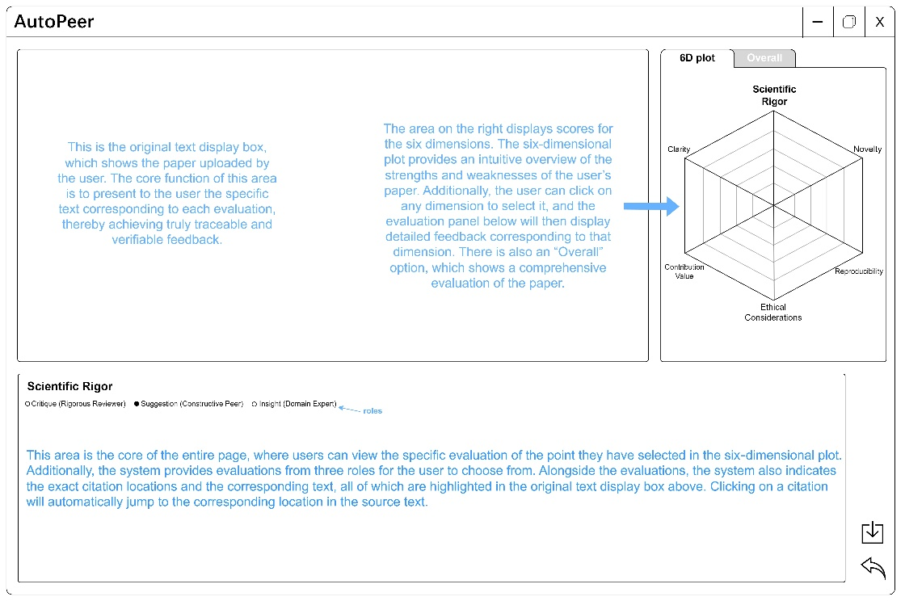
Figure 2

Part D: The Validation

5.0 Novelty and Contribution
Our proposed AutoPeer system represents a significant departure from existing Automated Essay Scoring (AES) tools and generic LLM-based review assistants. By addressing the critical gaps identified in the literature review—specifically the mismatch in research subjects (short essays vs. long papers), incomplete scoring criteria, and inconsistent feedback quality—AutoPeer offers four primary dimensions of novelty that collectively advance the state of the art in automated academic evaluation.

5.1 Innovation in Data Handling: Structured "Long-Context" Analysis
Most current systems treat input text as a flat sequence, which leads to "lost in the middle" phenomena when processing 10+ page academic PDFs. AutoPeer’s Innovation: We introduce a Hybrid Preprocessing Pipeline (combining Rule-based and Model-based parsing via SciBERT, as detailed in Section 4.2). Unlike traditional AES systems that rely on surface features (word count, syntax), and unlike vanilla LLM approaches that simply paste full text into a context window, our system "comprehends" the document structure before evaluation. By segmenting the paper into semantic blocks (Methodology, Experiments, Conclusion) and feeding these targeted sections into the review engine, AutoPeer ensures that feedback is not just grammatically correct but structurally context-aware. This directly solves the "domain transferability" problem where models trained on essays fail on scientific papers.

5.2 Methodological Novelty: The Multi-Role Integrated Prompting Strategy
A pervasive issue with RLHF-aligned LLMs (like GPT-4) is their tendency to be "sycophantic"—providing overly positive, vague, and non-confrontational feedback. AutoPeer’s Innovation: We propose a Multi-Role Integrated Prompting mechanism (Section 4.4.2) that forces the model to sequentially adopt distinct personas: The Rigorous Reviewer (finding flaws), The Constructive Peer (fixing issues), and The Domain Expert (assessing impact). This effectively creates a "committee of reviewers" within a single generation pass. By explicitly separating the "critique" step from the "suggestion" step, we mitigate the bias of generic positivity. Furthermore, the enforcement of Chain-of-Thought (CoT) reasoning for each role externalizes the "black box" judgment process, ensuring that scores are derived from logical deduction rather than intuitive jumps.

5.3 Rubric Expansion: Beyond "Writing Quality"
Existing automated scoring tools predominantly focus on Clarity and Grammar, ignoring the core scientific value of a paper. AutoPeer’s Innovation: We have defined a Six-Dimensional Academic Rubric (Section 4.4.1) that specifically targets the "blind spots" of current AI reviewers.
Reproducibility: By explicitly scanning for code availability and experimental parameters, we address the reproducibility crisis in AI research.
Ethical Considerations: We elevate ethics to a primary scoring dimension, ensuring that issues like data privacy and algorithmic bias are not overlooked—features completely absent in traditional e-rater systems. This rubric aligns AutoPeer with high-impact conference standards (e.g., ACL, NeurIPS), making it a domain-specific tool rather than a general-purpose writing aid.
5.4 Technical Contribution: The "White-Box" Verification Protocol
One of the biggest barriers to trusting AI reviewers is the "hallucination" problem. AutoPeer’s Innovation: We enforce a Citation-Mandated Output Protocol. The system is technically constrained (via JSON schema) to provide a specific Location (Section/Paragraph ID) and Original Text Quote for every piece of feedback generated. This transforms the review from an unverifiable opinion into an evidence-based report. This "locatable feedback" mechanism drastically improves upon the template-based suggestions of traditional NLP and the vague comments of zero-shot LLMs. Table 1 below summarizes the key distinctions between AutoPeer and existing approaches.
Feature / Capability | Traditional AES (e.g., e-rater) | Generic LLM Review (e.g., ChatGPT) | AutoPeer (Ours)
Input Handling | Surface features (grammar, length) | Full text (often truncated) | Structured Parsing (Section-aware)
Scoring Criteria | Writing quality only | General & vague | 6-Dim Academic Rubric (incl. Ethics)
Feedback Style | Template-based phrases | Polite, often overly positive | Critical & Constructive (Multi-Role)
Evidence Retrieval | None | Hallucination-prone | Locatable Citations (JSON-enforced)
Reproducibility Check | No | Limited | Specific Parameter Verification
Table 1: Comparison of AutoPeer with Existing Automated Review Approaches

6.0 Evaluation Plan
To rigorously validate the effectiveness of AutoPeer, we propose a comprehensive evaluation framework combining quantitative metrics (measuring scoring agreement) and qualitative analysis (assessing feedback utility). The evaluation will be conducted using a dataset constructed from open-access reviews in the ACL Anthology, providing a "Gold Standard" of human expert judgment.

6.1 Experimental Setup
Dataset Construction: We will curate a dataset of 100 papers from ACL 2023 and 2024 (Long Paper Track). For each paper, we will retrieve:
1.The original PDF submission.
2.The meta-review decision (Accept/Reject).
3.The individual human reviewer scores (converted to a 1-5 scale for normalization).
4.The textual review comments provided by human experts.
Baselines for Comparison:
1.Baseline A (Vanilla GPT-4): Using a standard zero-shot prompt ("Please review this paper and give a score from 1-5").
2.Baseline B (Traditional AES): A feature-based regression model (e.g., using linguistic features + SVM) to represent pre-LLM capabilities.
3.AutoPeer (Ours): The full pipeline including preprocessing, multi-role prompting, and JSON constraints.
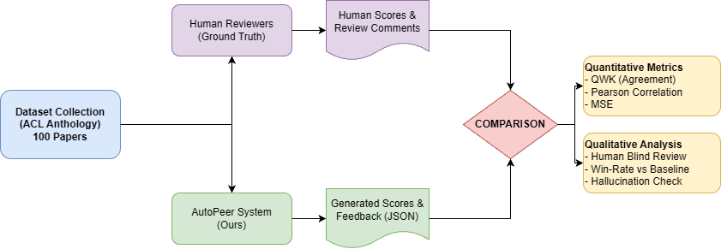
Figure 3 The proposed evaluation pipeline designed to measure both scoring agreement and feedback utility.

6.2 Quantitative Evaluation: Scoring Agreement
The primary goal is to determine if AutoPeer aligns with human expert consensus. We will use the following metrics:
1.Quadratic Weighted Kappa (QWK):This is the standard metric for Automated Essay Scoring11. It measures the agreement between two raters (System vs. Human Average) while penalizing large discrepancies more heavily than minor ones (e.g., scoring a paper 1 vs. 5 is penalized much more than 3 vs. 4).
Target: We aim for a QWK > 0.60, which generally indicates "substantial agreement" in psychometrics.
2.Pearson ($r$) and Spearman ($ρ$) Correlation:We will calculate the correlation coefficients between AutoPeer’s output scores and the average human scores across all six dimensions (Clarity, Novelty, etc.). This reveals whether the system correctly ranks papers from "weak" to "strong."
3.Mean Squared Error (MSE):To measure the absolute precision of the scores:
$$MSE=\frac{1}{n}\sum_{i=1}^{n}{(}Score_{AutoPeer}-Score_{Human})^{2}$$
Lower MSE indicates that the system's judgment is closer to the human ground truth.

6.3 Qualitative Evaluation: Feedback Quality (The "Turing Test" for Reviews)
Scores alone are insufficient; the textual feedback must be useful. Since there is no automatic metric for "constructiveness," we will employ a Human Evaluation Study.
Participants: We will recruit 10 PhD students or researchers in NLP as expert evaluators.
Procedure (Blind A/B Testing): For a subset of 20 papers, evaluators will be presented with two reviews side-by-side (blinded):
- Review A: Generated by AutoPeer.
- Review B: The original human review (or Baseline output).
Evaluation Criteria: Evaluators will rate each review on a 1-5 Likert scale for:
1.Usefulness: Does this review help the author improve the paper?
2.Specificity: Does the review cite specific evidence rather than making vague claims?
3.Fairness: Is the tone objective and professional?
4.Novelty Detection: Did the review accurately identify the paper's contribution?
Metric: We will calculate the "Win Rate" (percentage of times AutoPeer is preferred over the Baseline) and the average Likert scores.

6.4 Ablation Study: Validating Design Choices
To prove the necessity of our specific design components (Section 4.0), we will conduct ablation tests:
Effect of Preprocessing: Compare AutoPeer (Full) vs. AutoPeer (Raw PDF text) to quantify the improvement brought by the Structure Identification module.
Effect of Multi-Role: Compare the detailed multi-role prompt output against a single-role prompt to verify if the "Rigorous Reviewer" persona actually increases the detection of methodological flaws.

6.5 Validity of Citations (Hallucination Check)
Since we require the model to output citations (Section 4.4.2), we must verify them.
Metric: Citation Accuracy Rate. We will implement a script to automatically search for the citation.text extracted by the LLM within the original PDF content.
- Calculation: (Number of exact matches found in PDF / Total number of citations generated) * 100%.
- Goal: We target a >95% accuracy rate to ensure the system is not fabricating evidence (hallucinating).
Table 2 summarizes our planned evaluation metrics.
Metric Type | Specific Metric | Purpose | Target Goal
Agreement | Quadratic Weighted Kappa (QWK) | Measure inter-rater reliability penalizing large errors | > 0.60 (Substantial)
Correlation | Spearman’s $ρ$ | Assess ranking consistency | > 0.70
Precision | Hallucination Rate | Check validity of generated citations | < 5% Error
Utility | Win-Rate (A/B Testing) | Human preference for AutoPeer vs. Baseline | > 50%
Table 2: Summary of Evaluation Metrics

Part E: The Reality Check

7.0 Ethical Considerations and Limitations
Although AutoPeer introduces multiple innovative mechanisms to improve the quality and fairness of automated academic paper review, it is not without ethical risks and practical limitations. Below we candidly discuss the most critical issues and corresponding mitigation measures.

Bias Against Low-Resource and Non-English Languages
Large language models such as GPT-4 and LLaMA3 are trained predominantly on English-centric corpora, leading to systematic undervaluation of papers written in or focusing on low-resource languages. This may result in unfairly low Clarity or Novelty scores for multilingual or non-English submissions common in ACL tracks on multilingual NLP or low-resource settings.
Mitigation: Incorporate multilingual few-shot examples in prompts, conduct regular bias audits on language-diverse subsets of the ACL Anthology, and apply post-hoc score calibration for detected non-English content.

Domain Bias Induced by ACL Anthology Data
The ACL Anthology exhibits a clear disciplinary preference for core NLP subfields (e.g., machine translation, large-scale pre-training), potentially disadvantaging interdisciplinary, emerging, or niche topics (e.g., NLP for mental health, sign languages, or digital humanities). The model may unconsciously penalise less-represented research paradigms.
Mitigation: Diversify few-shot examples with papers from NeurIPS, EMNLP Findings, and domain-specific workshops; explicitly add prompt instructions requiring novelty to be judged independently of topic popularity.

Data Privacy and Manuscript Confidentiality
Uploading unpublished manuscripts to commercial cloud APIs (e.g., OpenAI GPT-4) risks leakage of novel ideas or proprietary datasets, especially for industry submissions or under-review papers.
Mitigation: Provide a switchable local deployment mode using LLaMA3; enforce automatic anonymisation of author names and affiliations before transmission; delete all data immediately after processing; and recommend the system only for open-access or post-decision papers in production use.

Risk of System Abuse and Forged Reviews
Malicious users could exploit AutoPeer to generate seemingly authentic high scores and positive feedback for low-quality or even plagiarised papers, thereby manipulating conference or journal decisions.
Mitigation: Embed cryptographic watermarks and audit logs in every output JSON; require human-in-the-loop verification for any official review process; and explicitly state in the user interface and documentation that AutoPeer output is advisory only and cannot replace human reviewers.

Technical Limitations on Extremely Long Contexts
Current LLMs have hard token limits (GPT-4-128k ≈ 90–100 pages). Papers exceeding this length, or those with numerous tables and appendices, may suffer from truncation, “lost-in-the-middle” phenomena, or increased hallucination rates. Additionally, the hybrid preprocessing pipeline may fail on highly irregular or scanned PDFs.
Mitigation: Implement recursive summarisation or Map-Reduce strategies for ultra-long documents in future iterations and clearly warn users when input exceeds safe context length.

8.0 Project Timeline:
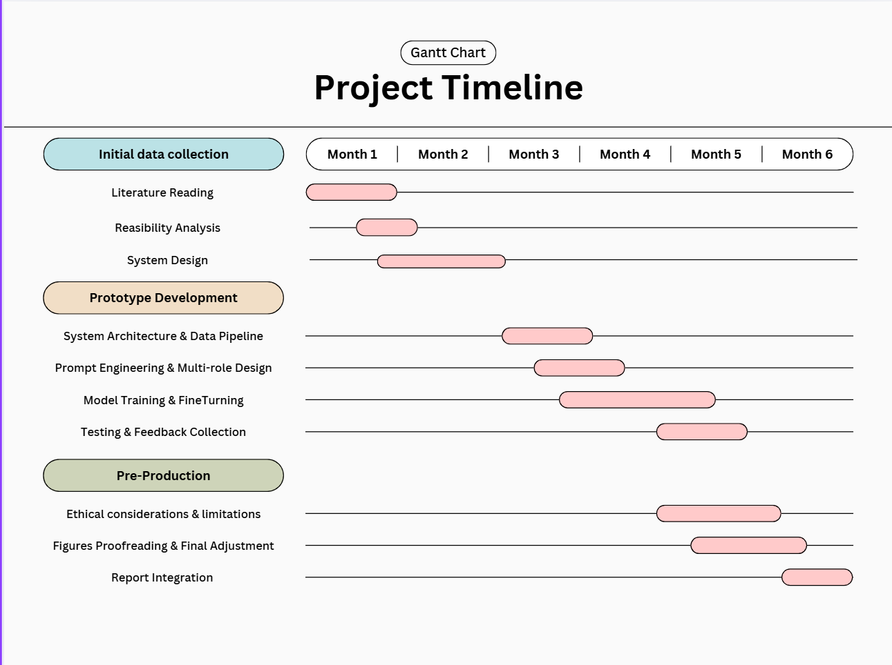
Figure 4 Gantt Chart of our project plan

Statement of Contribution
Student Name | Student ID | Primary Contribution
 | 50087483 | Part A: The Vision
 | 50087449 | Responsible for literature collection, organization and the compilation of Part B: Literature Review for the group assignment
 | 50087459 | Part C System Architecture and Design, Overall Architecture and Data Pipeline
 | 50087474 | Part C Core Model, Prompt Engineering / Fine-Tuning Details and Output and User Interface
 | 50087472 | Part D: The Validation
 | 50087461 | Part E and integrating the entire text

References
- Ke, Zixuan & Ng, Vincent. (2019). Automated Essay Scoring: A Survey of the State of the Art. 6300-6308. 10.24963/ijcai.2019/879.
- Tom B. Brown, Benjamin Mann, Nick Ryder, Melanie Subbiah, Jared Kaplan, Prafulla Dhariwal, Arvind Neelakantan, Pranav Shyam, Girish Sastry, Amanda Askell, et al. 2020. Language Models are Few-Shot Learners. In Advances in Neural Information Processing Systems (NeurIPS), Vol. 33, 1877–1901.
- Liang, Weixin & Zhang, Yuhui & Cao, Hancheng & Wang, Binglu & Ding, Daisy & Yang, Xinyu & Vodrahalli, Kailas & He, Siyu & Smith, Daniel & Yin, Yian & Mcfarland, Daniel & Zou, James. (2024). Can Large Language Models Provide Useful Feedback on Research Papers? A Large-Scale Empirical Analysis. NEJM AI. 1. 10.1056/AIoa2400196.
- Xiao, Changrong & Ma, Wenxing & Song, Qingping & Zhang, Kunpeng & Wang, Yufang & Fu, Qi. (2025). Human-AI Collaborative Essay Scoring: A Dual-Process Framework with LLMs. 10.1145/3706468.3706507.
- Rada Mihalcea and Paul Tarau. 2004. TextRank: Bringing Order into Texts. In Proceedings of EMNLP 2004, 404–411.
- Abigail See, Peter J. Liu, and Christopher D. Manning. 2017. Get To The Point: Summarization with Pointer-Generator Networks. In Proceedings of the 55th Annual Meeting of the ACL, 1073–1083.
- Anubhav Yadav. 2016. Automated Assessment of the Quality of Peer Reviews Using NLP Techniques. International Journal of Artificial Intelligence in Education, 26(2), 664–687.
- Aschermann, C., Frassetto, T., Holz, T., Jauernig, P., Sadeghi, A., & Teuchert, D. (2019). NAUTILUS: Fishing for Deep Bugs with Grammars. Proceedings 2019 Network and Distributed System Security Symposium.
- Ashish Vaswani, Noam Shazeer, Niki Parmar, Jakob Uszkoreit, Llion Jones, Aidan N. Gomez, Łukasz Kaiser, and Illia Polosukhin. 2017. Attention is All You Need. In Advances in Neural Information Processing Systems (NeurIPS), 5998–6008.
- Taejoon Han, et al. 2023. On Automated Essay Grading Using Large Language Models. In ACM ICCSAI Proceedings.
- Zhou, R., Chen, L., & Yu, K. (2024). Is LLM a Reliable Reviewer? A Comprehensive Evaluation of LLM on Automatic Paper Reviewing Tasks. International Conference on Language Resources and Evaluation.
- J. Atkinson and D. Palma. 2025. An LLM-based hybrid approach for enhanced automated essay scoring. Scientific Reports, 15, 87862.
- Atsushi Mizumoto and Masaki Eguchi. 2023. Large Language Models and Automated Essay Scoring of English Language Learner Writing. Computers & Education: Artificial Intelligence.
- Jonathan P. Tennant and Tony Ross-Hellauer. 2023. Fighting reviewer fatigue or amplifying bias? Considerations for LLMs in peer review. Research Integrity and Peer Review.
- Christian Grévisse. 2024. LLM-based automatic short answer grading in medical education. BMC Medical Education.
- Mizumoto, A., & Eguchi, M. (2023). Exploring the potential of using an AI language model for automated essay scoring. Research Methods in Applied Linguistics, 2, 100050. https://doi.org/10.1016/j.rmal.2023.100050
- Weixin Liang, Yuhui Zhang, Hancheng Cao, et al. arXiv preprint arXiv:2310.01783, 2023.
- Zhou, R., Chen, L., & Yu, K. (2024). Is LLM a Reliable Reviewer? A Comprehensive Evaluation of LLM on Automatic Paper Reviewing Tasks. In Proceedings of the 2024 Joint International Conference on Computational Linguistics, Language Resources and Evaluation (LREC-COLING 2024), pages 9340–9351.
- Atkinson, J., & Palma, D. (2025). An LLM-based hybrid approach for enhanced automated essay scoring. Scientific Reports, 15, 14551. https://doi.org/10.1038/s41598-025-87862-3
- Changrong Xiao, Wenxing Ma, Qingping Song, et al. arXiv preprint arXiv:2401.06431, 2024.
- Liew, P. Y., & Tan, I. K. T. (2024). On Automated Essay Grading using Large Language Models. In CSAI '24: Proceedings of the 2024 8th International Conference on Computer Science and Artificial Intelligence (pp. 204–211). ACM.
- Hosseini, M., & Horbach, S. P. J. M. (2023). Fighting reviewer fatigue or amplifying bias? Considerations and recommendations for use of ChatGPT and other large language models in scholarly peer review. Research Integrity and Peer Review, 8, 4. https://doi.org/10.1186/s41073-023-00133-5

